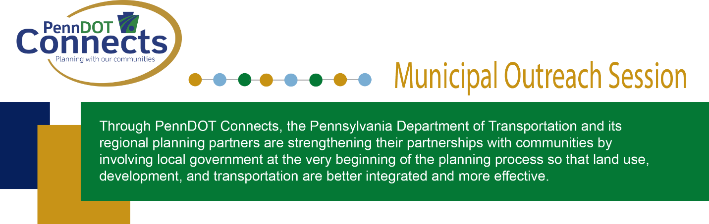

An Opportunity to Learn More about PennDOT Connects and Potential Funding Opportunities
The municipal outreach/peer exchange sessions will consist of interactive workshops that engage participants in peer exchange and idea-sharing. Municipalities will have the opportunity to interact with PennDOT, their local metropolitan planning organization or rural planning organization (MPO or RPO) staff and one another. Beginning with an overview of the PennDOT Connects Municipal Resources Program, the session will present the strategic priorities of PennDOT Connects and the community outcomes it supports. Participants will be encouraged to contribute their own ideas on how to take advantage of the program and to share their own best practices in planning, land use, and project delivery.

PennDOT Connects is an opportunity for communities to be heard and to improve transportation projects in ways that may have not been considered before or were recognized too late in the project delivery process. Attend a session near you to learn more about PennDOT Connects and the free resources available to municipalities.

Note: These sessions will focus on the resources available to municipalities through PennDOT Connects and not on specific projects on the Transportation Improvement Program (TIP) in PennDOT Districts.

Registration link: Register here

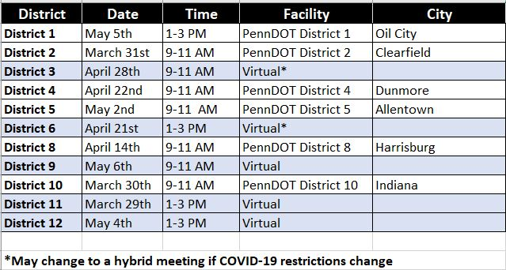

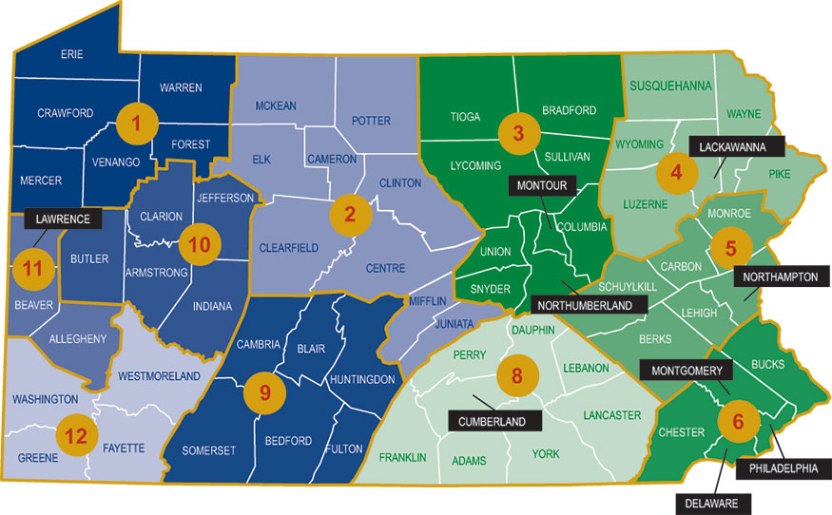

If participants need assistance for the virtual session, please call (717) 763-0930 ext. 194 or email PennDOTConnects@psats.org.

