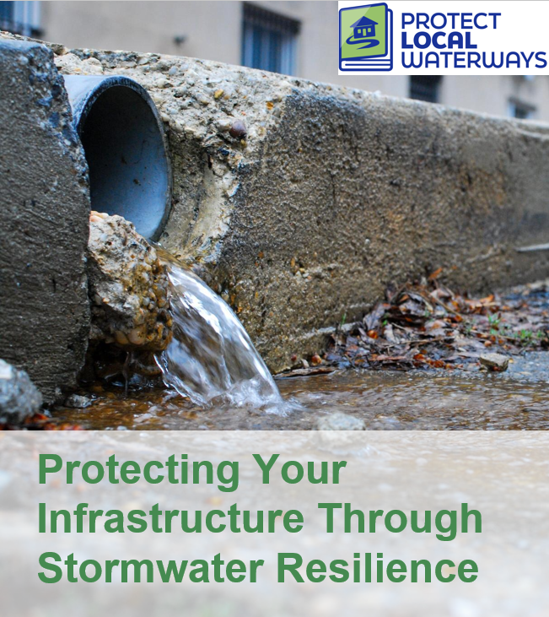

Did you know? November 16th is National Stormwater Day!

Stormwater is the water that flows off of impervious surfaces, like parking lots, roads and roofs. It can carry bacteria, nutrients, and other pollutants into local waterways. Excess stormwater can lead to flooding and cause damage to infrastructure, private property, and people.

As a local leader, your decisions set the course for your community. How your local government manages stormwater can have a big impact on the health and vitality of your community. Forests, wetlands, and other natural landscapes absorb rainwater and can provide cost-effective stormwater management.

Learn how you can Protect Your Infrastructure Through Stormwater Resilience. Visit us at ProtectLocalWaterways.org to learn more!

